GEETHANJALIINSTITUTEOFSCIENCE&TECHNOLOGY
(ANAUTONOMOUSINSTITUTION)
(Approved by AICTE, New Delhi & Affiliated to JNTUA, Ananthapuramu)(AccreditedbyNAACwith“A”Grade,NBA(EEE,ECE&ME)&ISO9001:2008CertifiedInstitution)
QUESTIONBANK(DESCRIPTIVE –12MARKS)

Subject Name with Code: Discrete Mathematical Structures---23A0015T
Course &Branch: B.Tech &Common to CSE,AIML,CS,DS
Year& Semester: IIB.Tech I Semester Regulation:RG23


UNIT-1
S.No. | Question |  | [BT Level] [CO]  [ Marks]
 |  | Check the validity of the following argument. If I go to school, then I attend all the classes. If I attend all classes, then I get A grade. I do not get grade A and I do not feel happy. Therefore, if I do not go to school then, I do not feel happy. |  | [1][CO1][10]
 |  | Using indirect method of proof, derive 𝑃⟶ ¬𝑆 from the premises 𝑃⟶ (𝑄∨𝑹), 𝑄 → ¬𝑃, S→ ¬𝑅𝑎𝑛𝑑𝑃. |  | [1][CO1][10]
[1][CO1][5]
[1][CO1][5]
 |  | - Define Well Formed Formula and Tautology with examples? |  | [1][CO1][5]  [1][CO1][5]
5. |  | a) Find the truth value of [(𝑃∨𝑄) ∧ (∼𝑅)] ↔ 𝑄 using truth table (5m)  b) Illustrate the principal disjunctive and conjunctive normal forms of (P →(Q∧R)) ∧(┐P→(┐Q∧┐R)) using Truth table. |  | [1][CO1][5]  [1][CO1][5]
6. |  | a) Define Well Formed Formula and Tautology with examples? (5m)  b) Explain in detail about the Connectives with Examples? (5m) |  | [1][CO1][5]  [1][CO1][5]
7. |  | 1. Test the Validity of the Following argument: ―All dogs are barking. Some animals aredogs. Therefore, some animals are barking.  2. Test the Validity of the Following argument:  ―Some cats are animals. Some dogs are animals. Therefore, some cats are dogs. |  | [1][CO1][5]  [1][CO1][5]
8. |  | Obtain PCNF and PDNF of the formula  P ->[(P -> Q)^~(~Q V ~P)] |  | [2][CO1][10]
9. |  | a) Define converse, contra positive and inverse of an implication? (5m)  b) show that (p→q) →q=pvq without constructing the Truth Table?(5M) |  | [1][CO1][5]  [1][CO1][5]
10. |  | a) Illustrate that ((P→R) V(Q→R))↔((PΛQ)→R) is tautology without using truth table?(5M)b)Explain in detail about the Connectives with Examples?(5M) |  | [1][CO1][5]  [1][CO1][5]

Q.No. | UNIT-II  (Set theory)
1. | Show that (S,≤) is a Lattice, where S= {1,2,5,10} and ≤ is for divisibility. Prove thatitisalsoa Distributive Lattice?(12m) | [2][CO3][12]
2. | SimplifythegivendatausingPrincipleofInclusionandExclusion:  In A survey of 100 students, it was found that 30 studied Mathematics, 54studied Statistics, 25 studied Operations Research, 1 studied all the threesubjects, 20 studied Mathematics and Statistics, 3 studied Mathematics andOperationsResearchand15studiedStatisticsandOperation Research.  - Findhowmanystudents studiednone ofthese subjects  - Find howmanystudents studiedonlyMathematics? (12m) | [4][CO3][12]
3. | Let G { 0,1,2, 3,4,5}  - Develop the Composition Table with respect to ‘+6’ (AdditionModulo 6)  - Showthat "G”isanAbelianGroup  - Findtheinverseofeachand everyelementin G.  - Find the order ofeach andeveryelementina Group(12m) | [3][CO3][12]
4. | - Interpret the value of f(2, 4) for function f(x, y) = x + y is primitiverecursive.(6m)  - Explainatleast3types of functionswithsuitable  examples?(6m) | [2][CO3][6]  [2][CO3][6]
5. | LetA={1,2,3,4,6,12}onAdefinetherelationRbyaRbifandonlyifadivides b.  a)showthat Ris apartial order onA?(6m) | [2][CO3][6]

 | b)construct the HasseDiagram forthis relation?(6m) | [3][CO3][6]
6. | Solve the inverse of the following functions with the proper steps:a)X={1,2,3},Y={p,q,r},andF={(1,p),(2,r),(3,q)}(4m)  b)F(x)=(3x+2)/(2x+1) (4m)  c)F(x)=sqrt(x+4)-3 (4m) | [3][CO3][4]  [3][CO3][4]  [3][CO3][4]
7. | - Let X = {1, 2, 3} and f, g, h and s be the functions from X to Xgiven by f = {(1, 2), (2, 3), (3, 1)} g = {(1, 2), (2, 1), (3, 3)} h = {(1,1), (2, 2), (3, 1)} s = {(1, 1), (2, 2), (3, 3)} Solveg ◦ f; f ◦ h ◦ g; s ◦g.(6m)  - Define Partition and Covering of a Set with suitable set of examplesforsatisfyingandnotsatisfyingconditionsforthedefinition?(6m) | [3][CO3][6]  [1][CO3][6]
8. | LetX={1,2,3,4,5,6,7} and R={(x, y/x-y is divisibleby 5} in x. Show  thatRisanequivalencerelation.(12m) | [2][CO3][6]
9. | - Define pigeon hole principle and what is the minimum no.ofstudents required in a class to be sure that atleast 6 studentswill receive the same grades if there are 5grades(A,B,C,D,E,F)?(4m)  - Explain compositionoffunctions? Letf andgbefunctionsfromRtoR, where R isasetofrealnumbersdefined by f(x)=x^2+ 3x+ 1andg(x)=2x−3.Interpretthecomposition offunctions:i)f◦f ii)f  - giii)g◦f.(8m) | [1][CO3][4]  [2][CO3][8]
10. | For a fixed integer n>1,show that the relation “congruentmodulon”isanequivalencerelationonthesetof all integers,  Z.(12m) | [2][CO3][12]

Q.No. | UNIT-III  (ElementaryCombinatorics)
1. | Fromacommitieeconsistingof6menand7womeninhowmanywayscan beselect a committeeof  - 3menand4women.  - 4memberswhichhasatleastonewomen.  - 4personsofbothsexes.  - 4person inwhich Mr.And Mrskannan isnot included | [1][CO4][12]
2. | In a town council there are 10 democrats (6 men, 4 women) and 11republicans (7 men, 4 women). Find the number of committees of 8councilorswhichhaveequal numberofmenandwomenandequalnumber  ofmembersfrombothparties | [1][CO4][12]
3. | FindthecoefficientsusingMultinomial Theorem:  I. x⁵y⁵z⁵w⁵in(x-3y +2z-5w)²⁰  II. xyz² in(2x-y-z)⁴ | [1][CO4][6]  [1][CO4][6]
4. | FindthecoefficientsusingBinomial Theorem:  (i) a²b³c²d ⁴ in(a +b)⁵ (c+d)⁶(ii) a ³b ² in(a +b)⁵ +(c+d)⁴.  (ii) X³Y ⁷in(i) (X+2Y)¹⁰ (ii)(2X-9Y)¹⁰ | [1][CO4][6]  [1][CO4][6]
5. | Find the number of ways in which the complete collection of letters thatappearin TALLAHASSEEcanbearranged in arowso that:  (i)Tappearsatthebeginningand Eappearsattheend.(ii) Thereareno  adjacent A’s | [1][CO4][12]
6. | ^{I.} Findthecoefficientof x⁵ y¹⁰ z⁵ w⁵⁽x-7y+3z-2w)²⁵  II. Howmanynon-negativeintegralsolutionsaretheretotheinequality x1+x2+x3+x4+x5<=19. | [1][CO4][6]  [1][CO4][6]
7. | Iftwo indistinguishabledicearerolled, then  - Howmany wayscan weget a sum of 4 orof8?  - Howmanyways wegetan even sum? | [1][CO4][6]  [1][CO4][6]
8. | Find the number of ways in which the complete collection of letters thatappearin MISSISSIPPIcan be arrangedin arowsothat:  (i)Sappearsatthebeginning(ii)TherearenoadjacentI’s | [1][CO4][12]

Q.No. | UNIT-IV  (RecurrenceRelations)
1. | Identifyis thesolution oftherecurrencerelation an=an-1+2an-2  witha0=2and a1=7? | [3][CO5][12]
2. | FindFibonacci recurrencerelation satisfytherecurrencerelation  fn=fn-1+fn-2withinitialconditions f0=0 andf1=1. | [1][CO5][12]
3. | Solverecurrencerelationan=6an-1–9an-2witha0=1anda1=6? | [3][CO5][12]
4. | FindtheCoefficientofa GeneratingFunction  I. x¹²inx³(1-2x)¹⁰  II. x⁰in (3x²-(2/x))¹⁵ | [1][CO5][12]
5. | - Solverecurrencerelation 4an-3an-1=0,n ≥1,a0=1  - Ifanis thesolution ofarecurrencerelation an+1=k.ananda3=153/49and a5=1377/2401. What is k? | [3][CO5][6]
 |  | [1][CO5][6]
6. | Solvetherecurrencerelationan– 3 an-2+2 an-3=0, n ≥ 3, a0=1, a1  =0, and a2=0 usingcharacter root functions | [3][CO5][12]
7. | Solve the following Recurrence relation by Substitution method.i. an=an-1+(1/n(n+1))wherea0=1  ii. an=an-1+n.3^{n} givena0=1 | [3][CO5][6]
 |  | [3][CO5][6]
8. | Findthe coefficient of x²⁷inthefollowing function  (x⁴+x⁵+x⁶+……)^{5.} | [1][CO5][12]
9. | - Findthesequenceof GeneratingFunction(3+x)³.  - Find the generating function for the sequence 0,1,-2,3,-4,….. | [1][CO5][6]
 |  | [1][CO5][6]
10. | Solvetherecurrencerelation2an+3=an+2 +2an+1-anwith  a0=0,a2=2and a1=1? | [3][CO5][12]

Q.No. | UNIT-V  (Graphs)
1. | Showthat themaximum numberofedgesinasimplegraphwithnvertices  is𝑛*(𝑛−1)/ 2 | [2][CO6][2]
2. | Construct all regular binary trees: (i) With exactly 7 vertices. (ii) Withexactly9 vertices. 5M | [3][CO6][12]
3. | - WriteKruskal'salgorithmforfindingaminimalspanningtree.  - FindtheminimumspanningtreeusingKruskal'salgorithm | [1][CO6][4]

 | 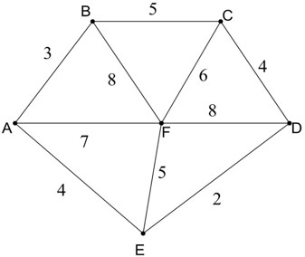 | [1][CO6][8]
4. | - Explainabout Eulercircuit,Euler walk,Eulergraph  - Explain about Hamiltonian circuit, Hamiltonian walk, Hamiltoniangraph  - IdentifywhetherthefollowinggraphsareEulerorHamiltonian.  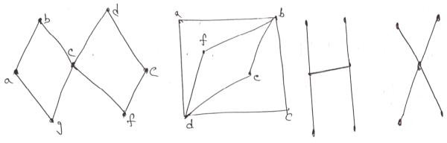 | [2][CO6][4]  [2][CO6][4]  [3][CO6][4]
5. | - ExplainEuler’sFormula orEuler’sTheorem?  - Forthegivenplanar graphshown below,  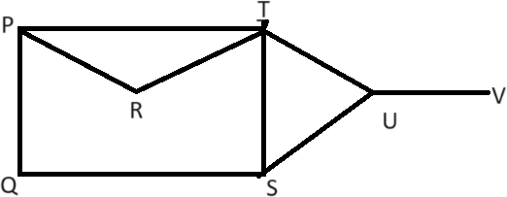  - ApplyEuler'sformulaandfind thedegreeof eachregion.  - Showthatsumofthesedegreesisequaltothetwicetheno.ofedges.  - Showthat followinggraph is verifiedby Euler's formula. | [2][CO6][3]  [3][CO6][3]  [2][CO6][3]  [2][CO6][3]
6. | - Explainminimumspanningtree.  - Build a minimum spanning tree of the following graph with propersteps.  3. 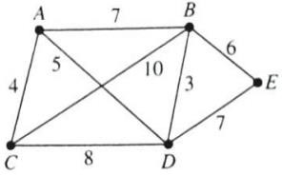 | [2][CO6][3]  [3][CO6][3]

7. | - Listtheconditionsinvolved inIsomorphism oftwographs  - Examine whether the given graphs are isomorphic to each other ornot?  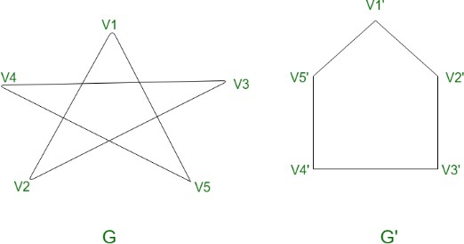 | [1][CO6][4]  [4][CO6][8]
8. | - Explain Graph Coloring and Chromatic Number of a graph withexamples.  - SolvePetersengraph(10vertices,15edages) andHerschel graph(11  vertices,18 edges) with proper graph Coloring and find thechromaticnumberfor eachgraph. | [2][CO6][4]  [3][CO6][8]

 | GEETHANJALIINSTITUTEOFSCIENCE&TECHNOLOGY  (ANAUTONOMOUSINSTITUTION)  (Approved by AICTE, New Delhi & Affiliated to JNTUA, Ananthapuramu)(AccreditedbyNAACwith“A”Grade,NBA(EEE,ECE,ME)&ISO9001:2008CertifiedInstitution)
QUESTIONBANK(2Marks)

SubjectNamewithCode:DiscreteMathematicalStructures---22A0017T
Course&Branch:B.Tech &CommontoCSE,AIML,CS,DS
Year&Semester:IIB.TechISemester Regulation:RG22

Q.No. | UNIT-I  (Mathematical Logic)
1. | What is tautology? Give some examples for it? | [1][CO1[2]
2. | Explain WFF and duality with examples? | [1][CO1][2]
3. | Define converse,contrapositive and inverse of an implication? | [1][CO1][2]
4. | Explain about PDNF with examples? | [2][CO1][2]
5. | What is duality law? Give suitable example? | [2][CO1][2]
6. | Construct the Truth table for~(~p^~q)? | [1][CO1][2]

Q.No. | UNIT-II  (Set theory)
1. | Define a binary relation. | [2][CO2][2]
2. | Define as semi group with example. | [2][CO2][2]
3. | State the Pigeonhole principle. | [1][CO2][2]
4. | Define semi group and monoid. Give an example of a semi group which is not a monoid | [2][CO2][2]
5. | Define inverse function with example? | [2][CO2][2]

Q.No. | UNIT-III  (Elementary Combinatorics)
1. | State the Multinomial theorem.? | [2][CO3][2]
2. | State binomial theorem? | [1][CO3][2]
3. | In how many way scan6 personsoccupy3vacant seats? | [2][CO3][2]
4. | Differences between permutation and combination? | [2][CO3][2]

Q.No. | UNIT-IV  (Recurrence Relations)
1. | Find the recurrence relation of theFibonaccisequence.2M | [2][CO4][2]
2. | Find the closed form of the generating function for the sequence “ s” withterms1,2,3,4…….. | [2][CO4][2]
3. | Find the coefficient of X¹⁴ in (1+X+X²+X³ )¹⁰. | [1][CO4][2]
4. | Find the coefficient of y¹⁷ in (1-y+y² -4y³)¹⁶. | [2][CO4][2]
 |  | [2][CO4][2]

Q.No. | UNIT-V  (Graphs)
1. | Define chromatic number? Give suitable example | [2][CO5][2]
2. | Explain Euler formula? Give suitable example | [2][CO5][2]
3. | Define Bipartite graph? Give suitable example | [2][CO5][2]
4. | Define Binary tree? Give suitable example | [2][CO2][2]
5. | Explain Four color theorem? Give suitable example | [2][CO2][2]
6. | When do you say that a graph is minimally connected? | [2][CO6][2]
7. | Define a planar graph.? Give suitable example. | [2][CO6][2]

Prepared By:(

